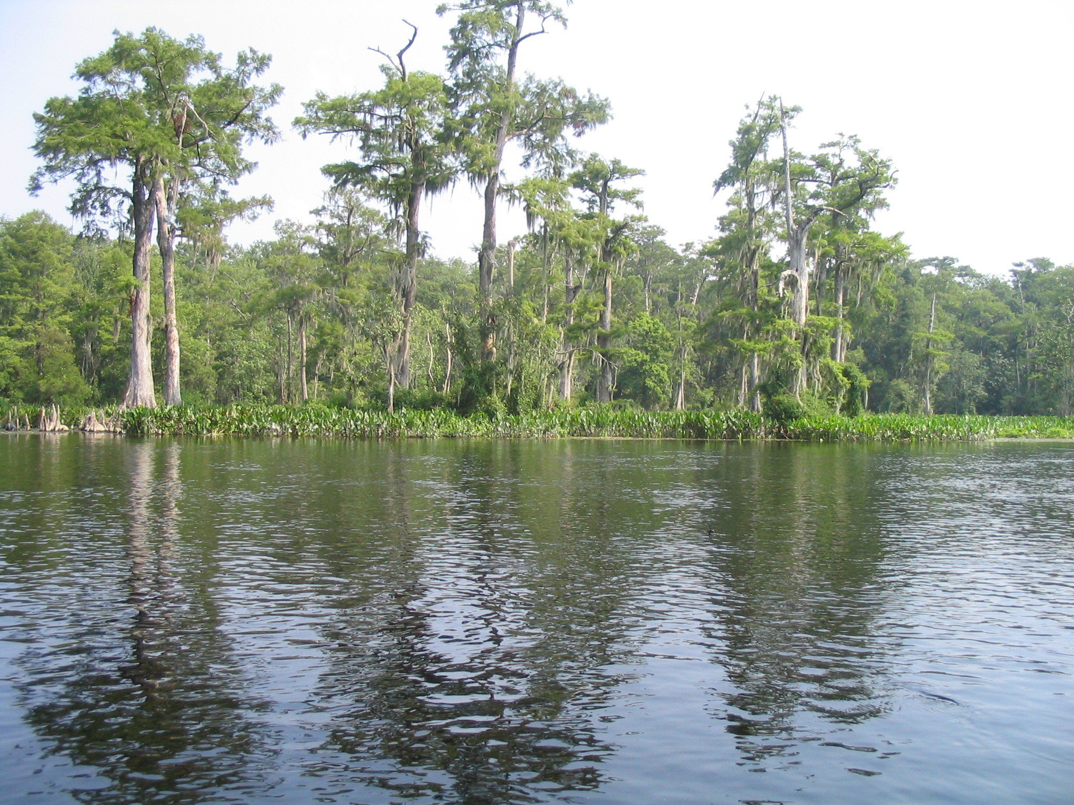

Lake Bradford Economic Impact Study

Florida State University
Center for Economic Forecasting and Analysis
2035 East Paul Dirac Drive
Suite 130, Morgan Building
Tallahassee, Florida, 32310
Julie Harrington, Ph.D., and Tim Lynch, Ph.D.
(850) 645-0190
jharrington@cefa.fsu.edu

September 14, 2005

Lake Bradford Economic Impact Study

According to a study conducted in 1981 by Dana Bryan, Lake Bradford and nearby Grassy Lake and Black Swamp are in a drainage basin located in a coastal area between the Aucilla and Ochlockonee Rivers. It is theorized that Lake Bradford is 3-4 million years old, and might have originated in sinkholes along a stream valley. Lake Bradford encompasses a wide variety of habitats that support mammals, birds, amphibians, reptiles, fishes, insects, zooplankton, and plant life. In addition, Lake Bradford sustains groups including homeowners, the Tallahassee Museum of History and Natural Science (a.k.a the Jr Museum), and the Florida State University (FSU) Reservation. Lake Bradford users enjoy a range of recreation activities, including canoe-trips, kayaking, sailing, swimming, fishing, hiking, and birding, among others.

An economic impact study was performed, by FSU, which examined the economic contribution of two businesses whose livelihood is based on the shores of Lake Bradford; the Tallahassee Museum of History and Natural Science and the FSU Reservation on the Leon County economy. The economic analysis excludes “returns” to the local economy that are not financial benefits (these are known as “non-pecuniary/non-market” or “intangible” benefits). These intangible benefits include those associated with the value of wildlife, clean water, education, etc. that are difficult to quantify. Therefore, the assumptions used to estimate the economic return to the local economy in this analysis can be characterized as conservative. These impacts were determined by estimating the direct and indirect stimulus to the local economy from direct spending of visitors, students and faculty attending the Museum and FSU reservation. FSU economists used an economic impact model that employs the direct measures of local expenditures over the 2004 period by visitors including:

- Tickets and memberships
- Retail purchases
- Education activities; camps
- Other activities, including grants, fundraising and donations

Table 1 provides the final direct, indirect and induced (secondary or multiplier) impacts from the Museum and FSU Reservation. The total economic stimulus is $3.1 million with income generation effects of $1.1 million. The equivalent of 42 jobs were created in the local area as a result of the spending. Finally, Federal, State and Local taxes generated were $246,000.

Table 1. Economic Impact Results of the Tallahassee Museum of History and Natural Sciences and the Florida State University Reservation

Both the Museum and FSU reservation serve as a major stimulus to the local economy, with a multiplier effect of 1.8. The economic benefits extend to job creation; generation of output or sales, personal income, and taxes. Clearly, Lake Bradford’s water quality and overall good health are critical to providing a positive impact to the local economy.

